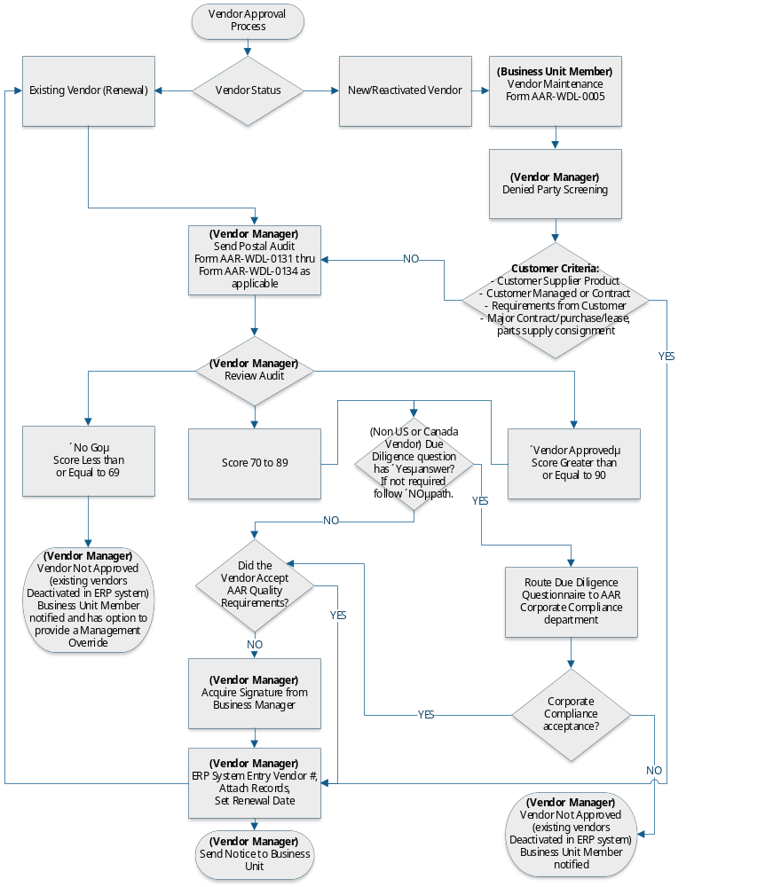

Supplier / Vendor Type | Supplier / Vendor Description
OEM | Original Equipment Manufacturers (OEM) Airframe or Engine Manufacturers and their approved suppliers
PMA / TSO | Production Approval Holders (PAH), Parts Manufacturer Approval Holders (PMA) and Technical Standard Order Manufacturers (TSO).
FAA Operator | Certified Operator certified under FAA FAR 121,129,135
Foreign Operator | IATA or other operators of commercial and regional aircraft as verified in ACAS.
FAA 145 | Repair Stations certified under Federal Aviation Agency FAR 145.
TCCA | Certified under the Transport Canada Civil Aviation Repair Station
OEM Spares /Distributor | A unit of a corporation that sells new or used products manufactured by that corporation. If material manufactured by another corporation is purchased from this type of supplier that item is subject to the same criteria applied to non-regulated supplier. A letter or other document, acceptable to Quality Management must be reviewed, approved and filed.
Non-Regulated | All other Suppliers (brokers, distributors).
Local Contractors | (Maintenance contractors, etc., 3rd party certification bodies, etc.)

Type of Vendor | IMOPS Activation | Activation periods will be identified in IMOPS
Service Providers, OEM | RO and/or PO | 2 Years
Parts Distributors, Non-Regulated, Brokers, Non-Aviation | PO | 2 years
A Service Provider Vendor will automatically become PO approved when added to the Approved Vendors List.

